Sitecore Module

# **Sitecore Hackathon 2017**

User Audit Report

## Handcrafted by #Error404 team:

Wojciech Urban

Tomasz Juranek

Robert Dębowski

-Poland-

**Category**:

**Habitat**  
If you are a Sitecore developer you must have heard of Habitat. There are numerous way Habitat can be used and extended. Do you have an idea on missing functionality? This is your moment to shine and share you Habitat module

## Module Pupose, What problem was solved?

Each day Sitecore as application is used by many content editor around the world. They work hard to put new content, to manage thousands of sites, components, millions of fields inside. Today we have to ask a question, could we take some reports of their work ? Could we check which of those elements on the page are frequently changed ? Which of Content Editors is the hardest worker ? How to optimize our content and content editing process ?

Every of above questions didn’t have clear answer – until today.

#Error404 presents **User Audit Report Module**

## How did you solve it, What is the end result

Overview:

#Error404 Team has prepared purely new Sitecore Module based on Sitecore 8.2 Update 1. It adds new button on Sitecore Dashboard. It allows to move in the new Speak View where we prepared reports of content changes. Results can be displayed using filters to select only one user for instance. Module contains also settings node in system/modules/Users Audit Reports where we can select which roles have to be tracked during building reports. It’s done by new custom RolesMultilist field.

According to reports, they are gathering information from content managing events like save or copy and collecting them in MongoDB. Afterwards those information are presented in new Speak Application view.

## Installation

Installation Guide Steps:

1. Check if MongoDB is working correctly on the machine

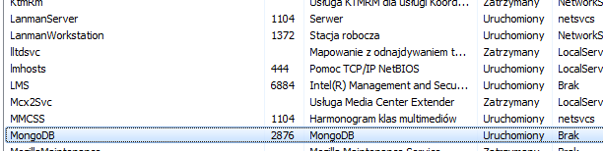

1. Add to ConnectionStrings.config file new record to MongoDB like below - change server and port according to your local settings:

<add name="tracking.reports" connectionString="mongodb://localhost:27017/habitat_tracking_reports" />



1. Install package using Sitecore installation wizard

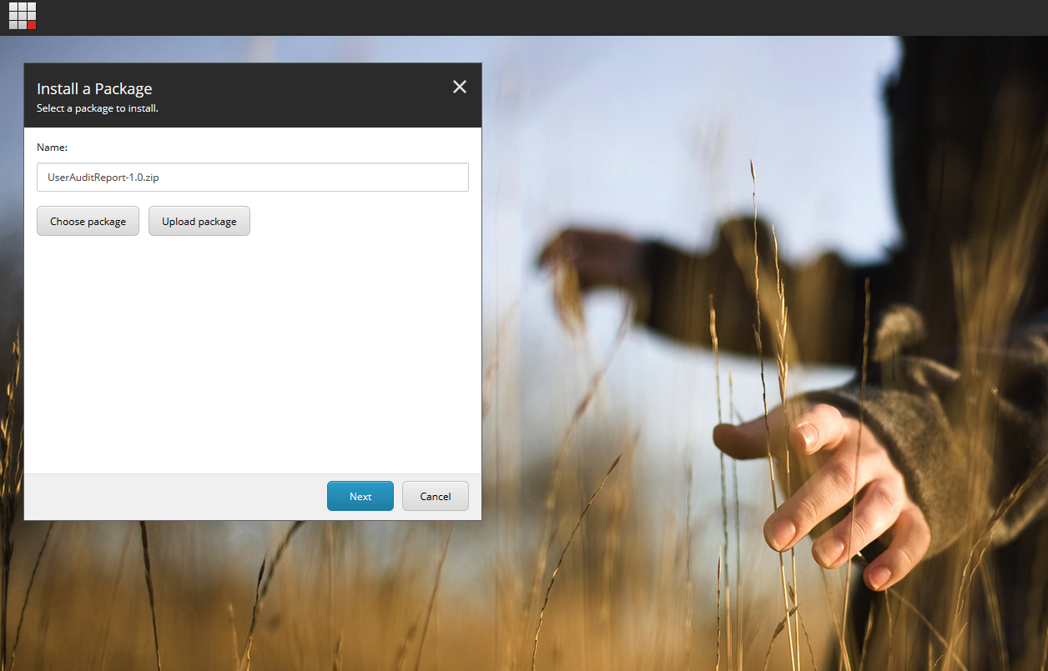

## Module Usage Details

To use User Audit Report module has to remember about main things:

##### Module setting node

Here it’s possibility to select which roles from Sitecore have to be tracked by reports system. It’s provided by **new custom RolesMultilist field**.

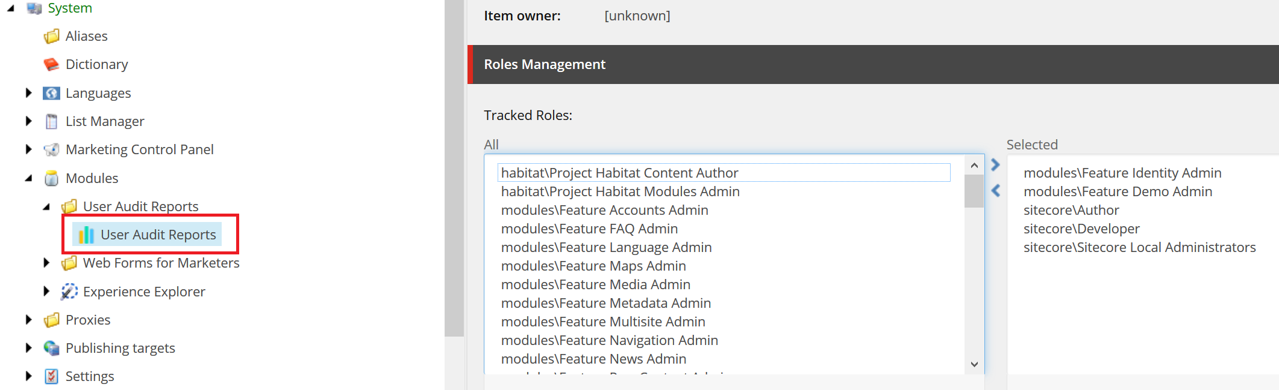

Module settings node is based on template:

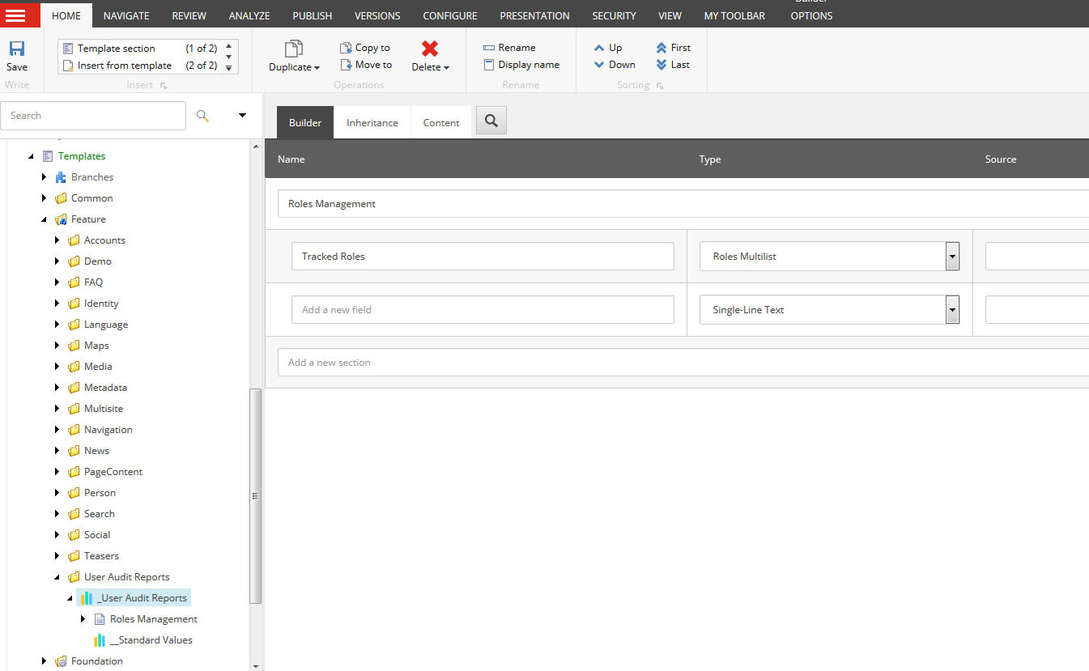

In connection with this node, new field type - Roles Multilist has been added. It’s added to DB Core and register in Sitecore as well.

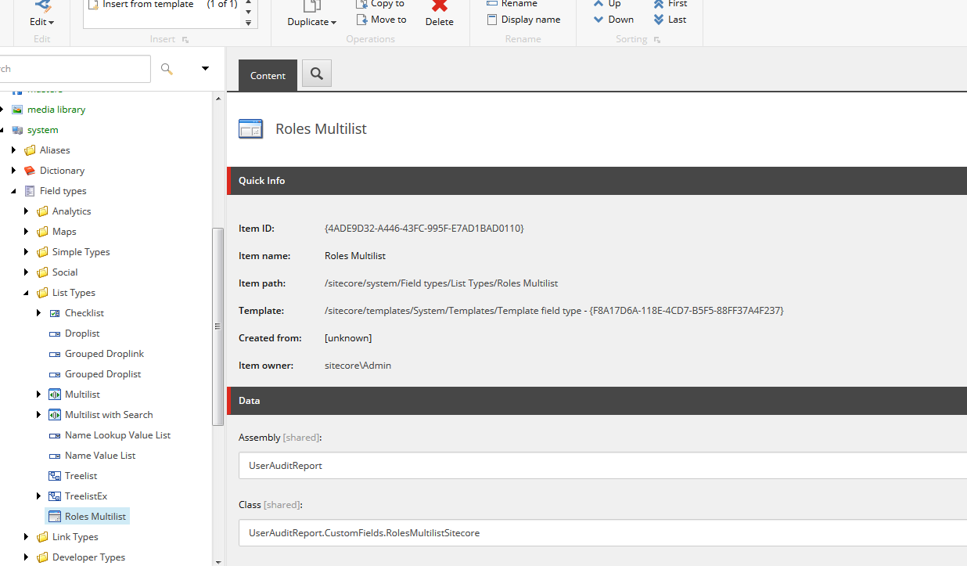

##### User Audit Report button on Dashboard

Here is the place to see purposed reports. That button redirect user to new Speak Application that display whole information which options to filter.

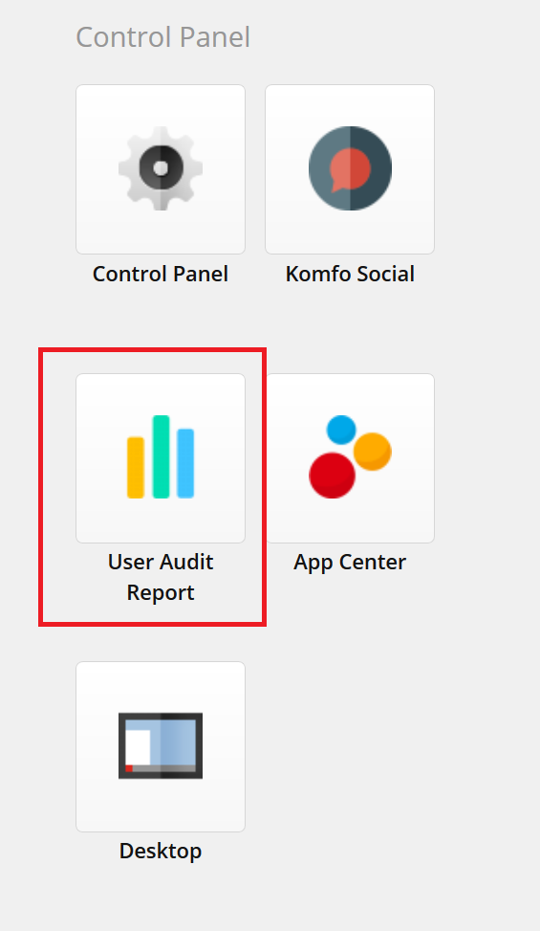

It’s possible to filter the results by user name and by date period. Also after clicking on a row, detailed information about all changes done by the user appears:

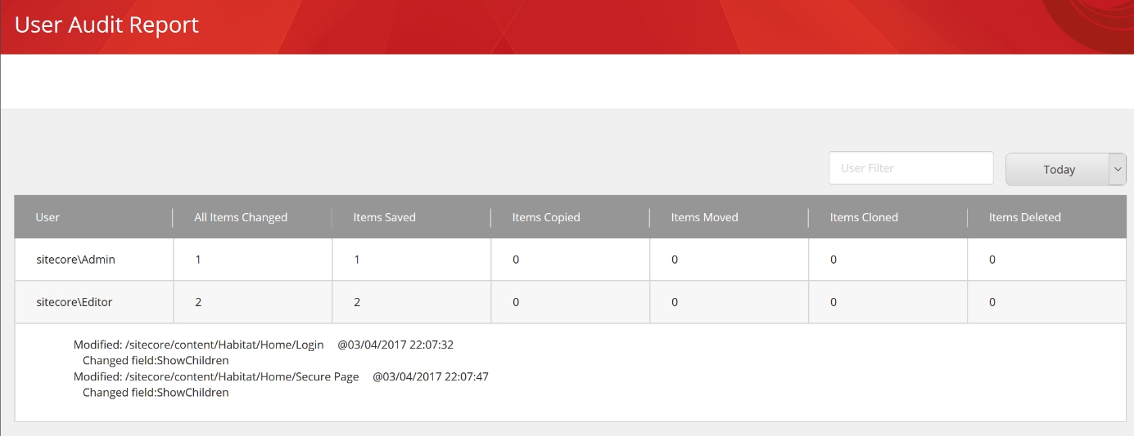

**How it works?**

***Use case:***

1. Admin/Manager define in System/Modules/User Audit Reports/User Audit Reports roles that have to be tracked by the User Agent Reports module
2. Module is gathering information about each user changes who contains one of the selected roles
3. Information are displayed in User Audit Reports application in Dashboard. There are options to filter and select some particular information that we would like to see. We also see what was the previous field value and what is the new one.

Reports are gather information from actions below:

* Save
* Delete
* Copy
* Move
* Clone

Information about changes done by particular tracked user are collecting in MongoDB and from there later are getting to present in Speak Application.

Structure of data in MongoDB:

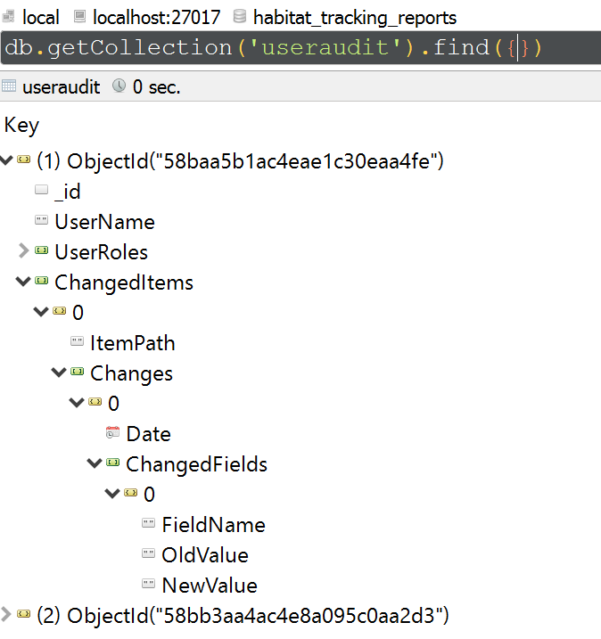

## Summary

We are really glad that we could create this module. In our opinion it based on many interesting solutions and it has a lot of option to extend. We hope that it helps many content editors to optimize their work. Best regards - #Error404 Team ☺